Remove food from a particular day

Document Information

|  |  |
| --- | --- |
| **Document Title** | Title of use case – Verb Noun phrasing is almost always the most appropriate! |
| **Document Owner** |  |
| **Version** |  |
| **Status** |  |
| **Date** |  |

1. Brief Description

This use case use case allows school administrators to remove a food item from the menu of a particular day. This functionality ensures that the food item is no longer available for students and parents to order.

1. Actors

* School Administrator

1. Trigger

The school administrator wants to remove a food item from a particular day.

1. Pre-Conditions

* The school administrator must be logged in to the system.
* The food item must have already been added to the menu of the particular day.

1. Post-Conditions

* The selected food item is removed from the menu of the particular day.
* The food item will not be available for students and parents to order.

1. Basic Flow
2. The school administrator selects the "Lunch Schedule" menu.
3. The system displays a calendar for the administrator to select a specific day.
4. The school administrator selects a day.
5. The system displays the food items that have already been added for that day.
6. The school administrator selects the food item to be removed.
7. The school administrator selects the “Save” button
8. The system removes the food item from the menu of the selected day.
9. The system displays the updated food items list.
10. Alternate Flows
11. Exception Flows

* 5a. If there are no food items to remove, the system displays a message "No food items found.".
* 5b. If the school administrator selects the wrong food item, they can unselect the check box to cancel.
* 5c. If the school administrator wants to remove multiple food items, they can select multiple food items.
* 7a. If there is an error in removing the food item, the system displays an error message and the system returns to food item list of the selected day and school administrator can retry the action.

1. Business Rules

* Only the school administrator can remove food items from the lunch menu.
* The lunch schedule can not be updated for days in the past.

1. Non-Functional Requirements

* The system must save the changes immediately after the food items are removed (1s).

1. Supplemental Requirements
2. Visual Model

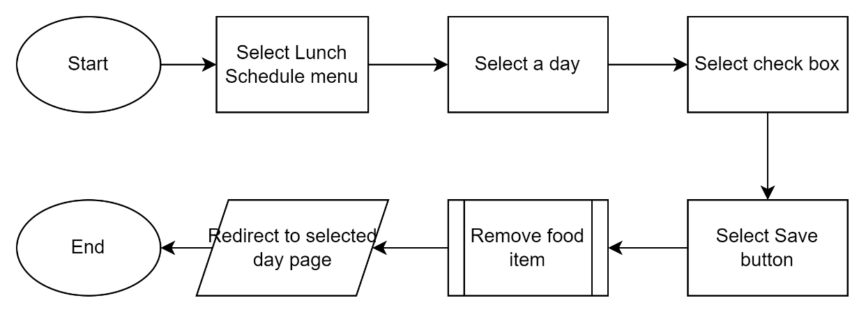

Revision History

|  |  |  |  |  |
| --- | --- | --- | --- | --- |
| V. | Date | Author | Description | Status |
|  |  |  |  |  |
|  |  |  |  |  |